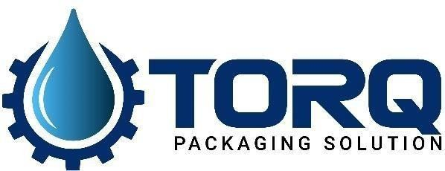
34, VISHALA ESTATE, S.P.RING ROAD,OPP.ODHAV TO NIKOL
ROAD, NIKOL, Ahmedabad, Gujarat, 382350
GST NO:-:24ARDPD2565K1Z

Info@torqpackagingsolution.com
www.torqpackagingsolution.com
Date: - 15/10/22

To,
Mr. Paresh
Rajkot, Gujarat

Sub: - Terms and condition for Milk Filling Machine

Dear Sir,
As per our discussion we are agree to make machine for milk filling machine. And we will take 80,000 INR as an advance for the machine. We both are agree as below condition for machine.
- machine contact parts will be ss 316
- working principal of the machine is gravity filling
- covering parts filling and capping machine will be ss 304.
- Shrink tunnel will be made from MS which is powder coated.
- Pneumatic parts will be janatics , HMI, PLC will be delta or inovance.
- If filling machine is not working as per given specification, we will agree to take back that filling machine and proceed for refund.
- Speed of the filling machine will be 2 -3 cycle can be more after taking trial in material.
- After receiving advance, machine will be ready in 25 to 30 working days.
- Remaining payment will be paid after trial at factory before dispatch.

Thanks & Regards Ronak Dave
+91 80000 32128

